Design Database model for Guvi-Zen

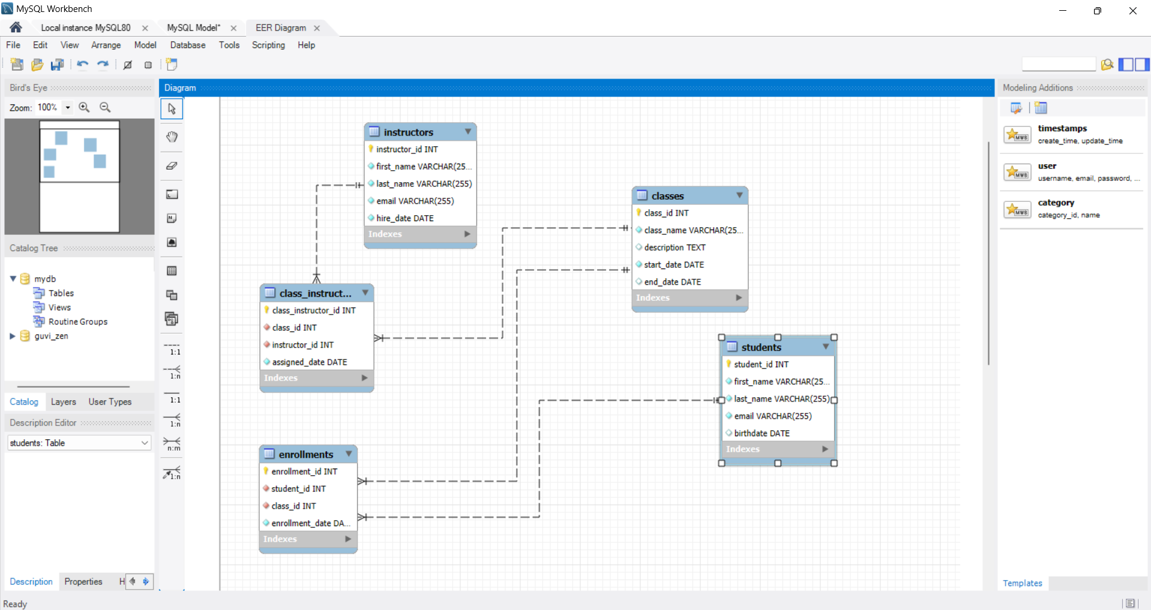

**Step by step Instructions**

Step 1: create database guvi_zen_class;

Step 2: Create Tables

**1.Classes Table**

CREATE TABLE classes (

class_id INT AUTO_INCREMENT PRIMARY KEY,

class_name VARCHAR(255) NOT NULL,

description TEXT,

start_date DATE NOT NULL,

end_date DATE

);

**2.Students Table**

CREATE TABLE students (

student_id INT AUTO_INCREMENT PRIMARY KEY,

first_name VARCHAR(255) NOT NULL,

last_name VARCHAR(255) NOT NULL,

email VARCHAR(255) NOT NULL UNIQUE,

birthdate DATE

);

**3.Enrollments Table**

CREATE TABLE enrollments (

enrollment_id INT AUTO_INCREMENT PRIMARY KEY,

student_id INT NOT NULL,

class_id INT NOT NULL,

enrollment_date DATE NOT NULL,

FOREIGN KEY (student_id) REFERENCES students(student_id),

FOREIGN KEY (class_id) REFERENCES classes(class_id)

);

**4.Instructors Table**

CREATE TABLE instructors (

instructor_id INT AUTO_INCREMENT PRIMARY KEY,

first_name VARCHAR(255) NOT NULL,

last_name VARCHAR(255) NOT NULL,

email VARCHAR(255) NOT NULL UNIQUE,

hire_date DATE NOT NULL

);

**5.Class_Instructors Table**

CREATE TABLE class_instructors (

class_instructor_id INT AUTO_INCREMENT PRIMARY KEY,

class_id INT NOT NULL,

instructor_id INT NOT NULL,

assigned_date DATE NOT NULL,

FOREIGN KEY (class_id) REFERENCES classes(class_id),

FOREIGN KEY (instructor_id) REFERENCES instructors(instructor_id)

);

Step 3: Verify the Schema

**SHOW TABLES;**